Nama : Andri Firman Saputra  
NIM : 201011402125  
Kelas : 05TPLP016  
Tugas : Basis Data II – Latihan 10

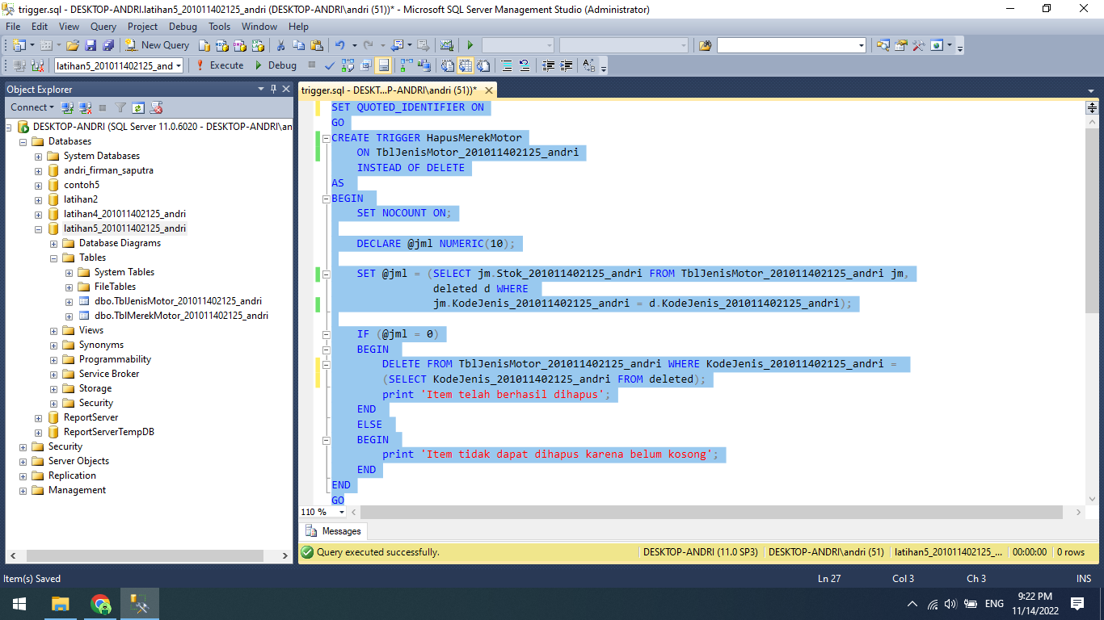

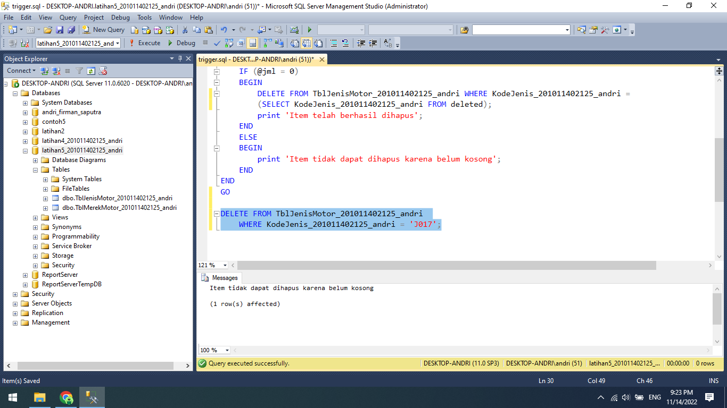

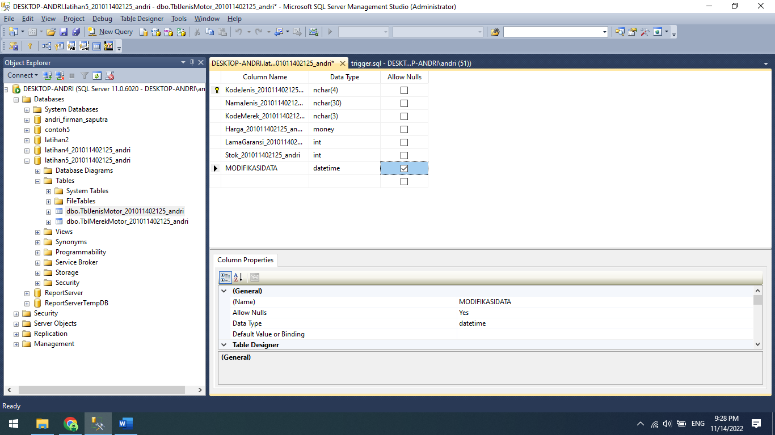

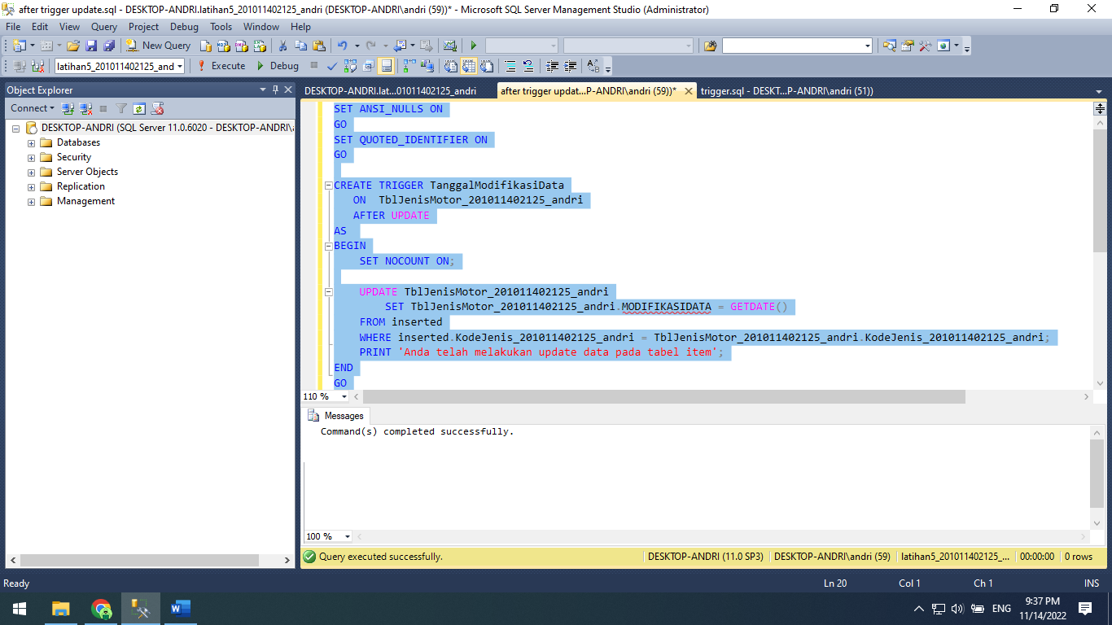

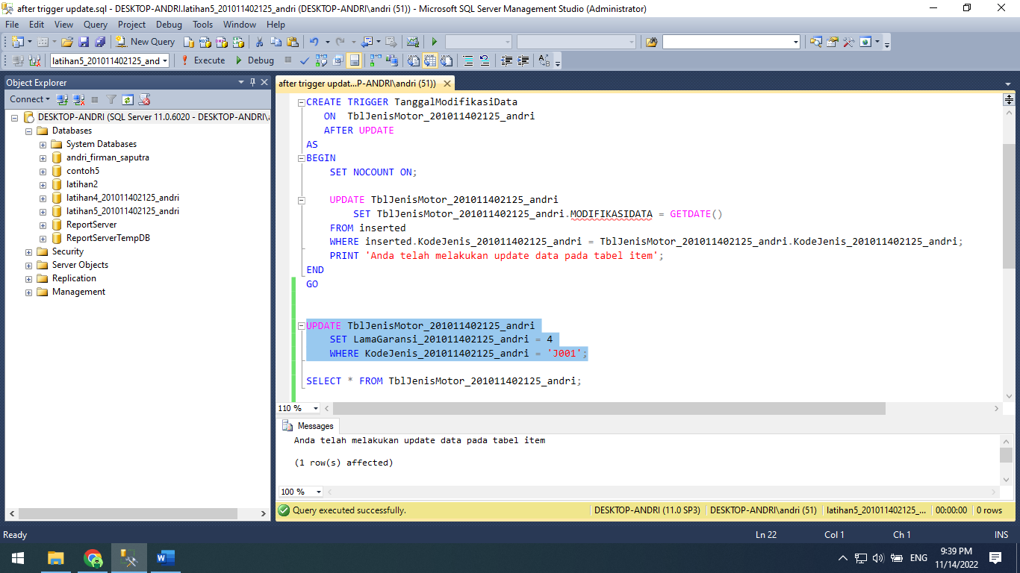

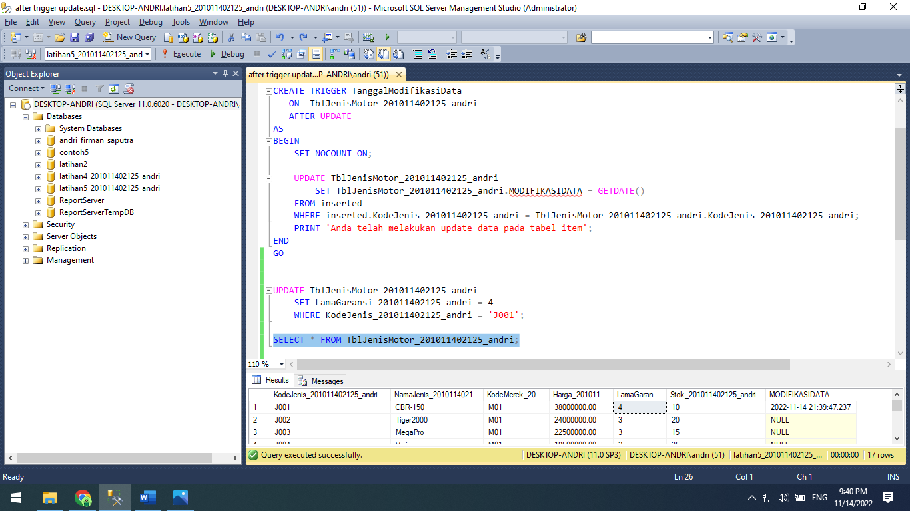

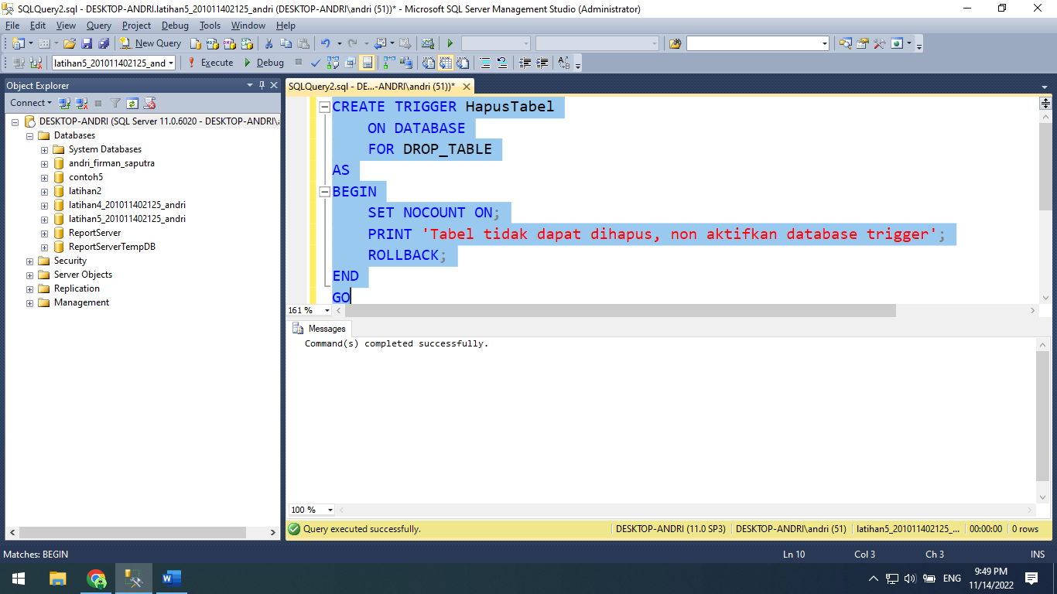

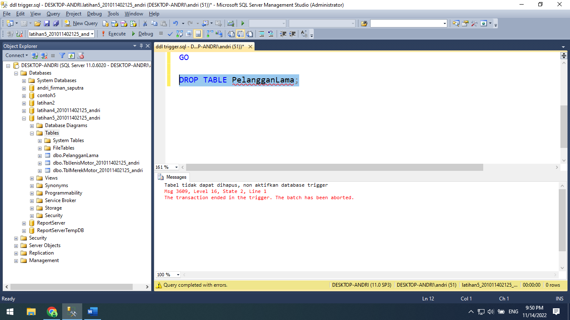

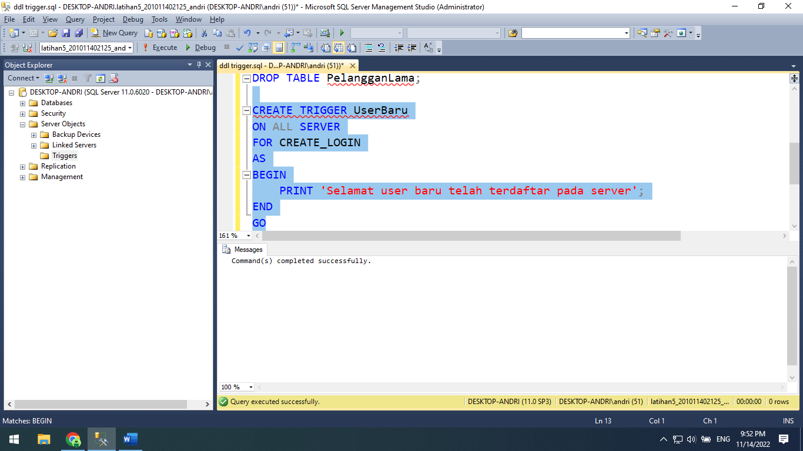

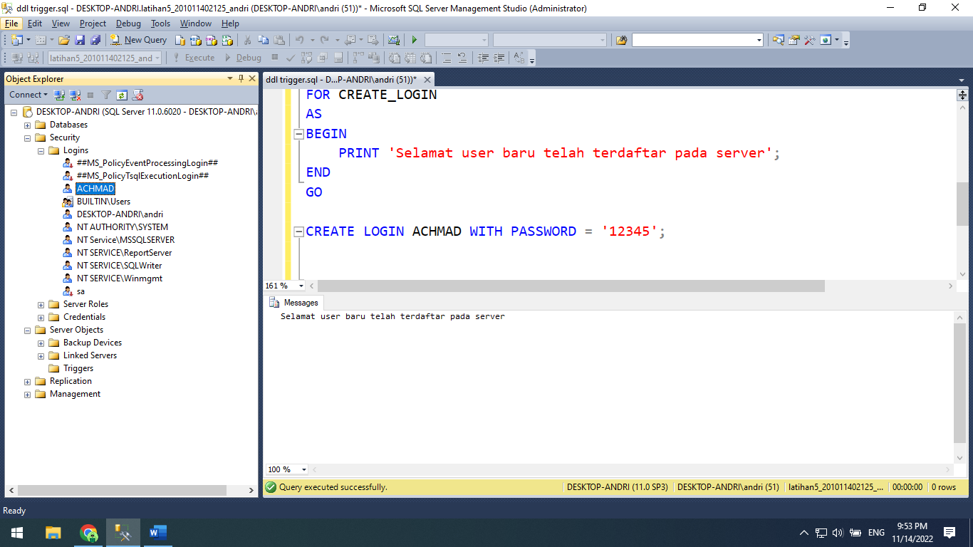

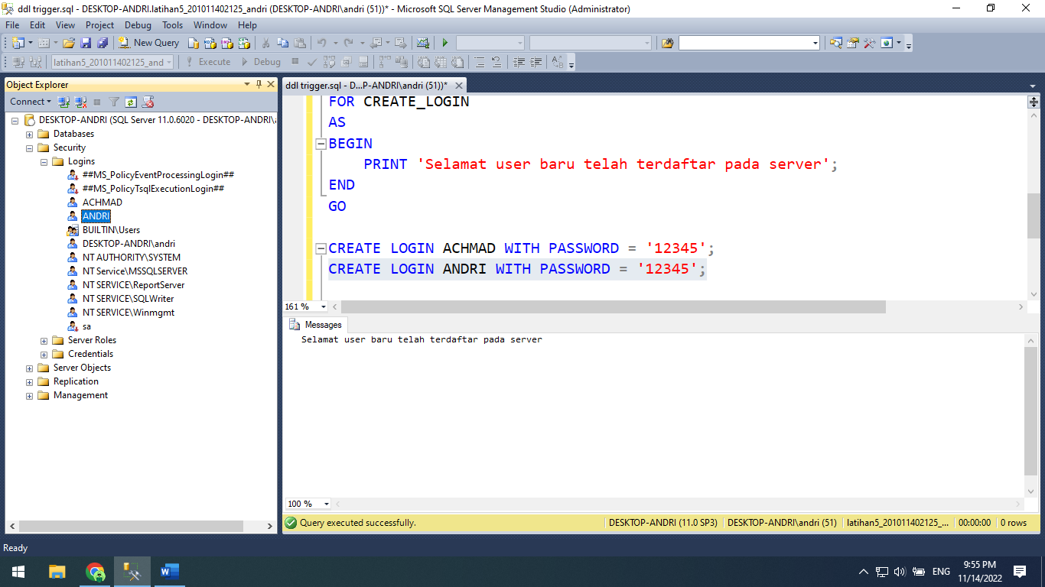

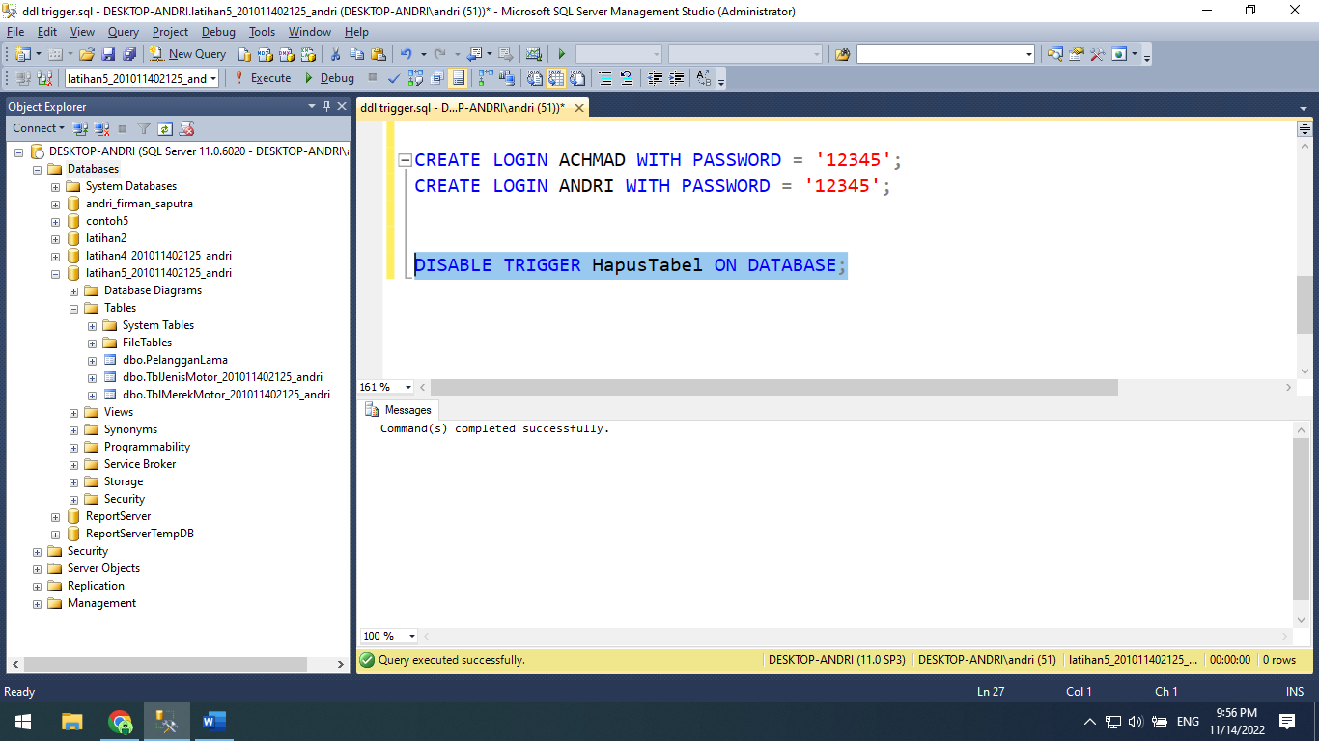

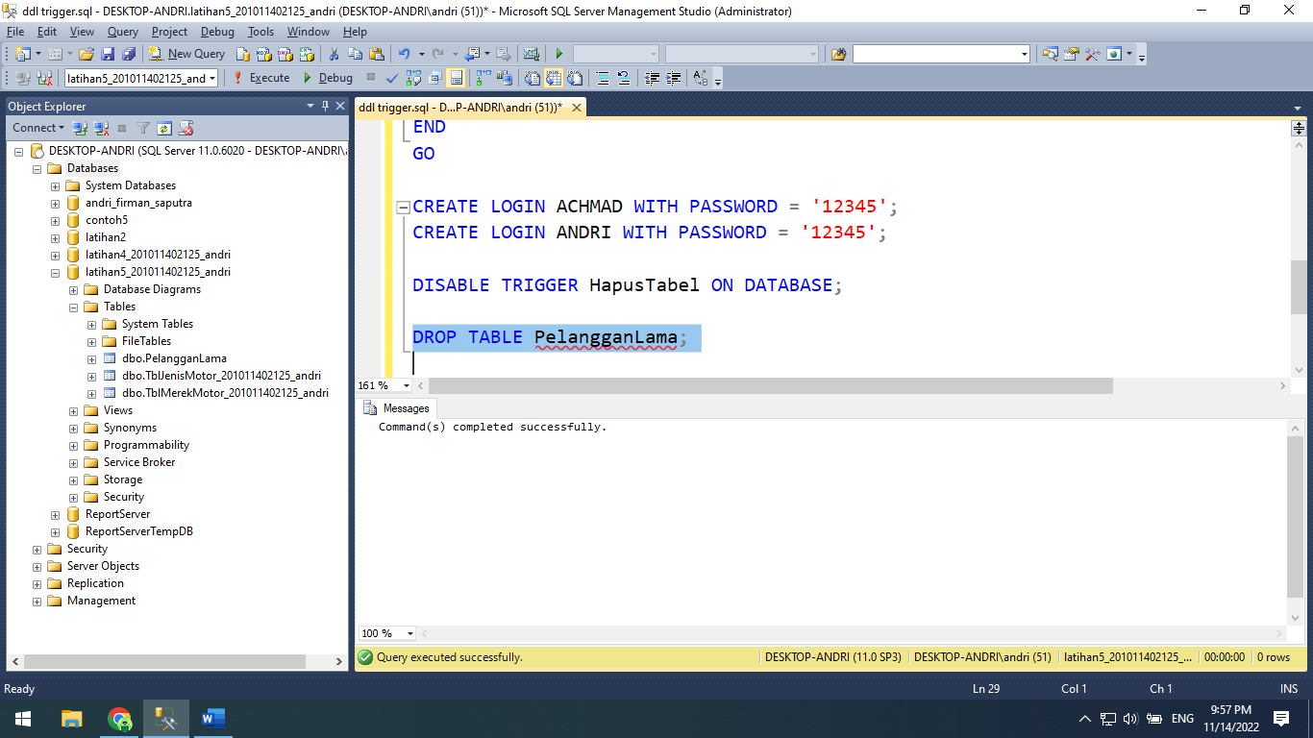

**Source code:**

SET QUOTED_IDENTIFIER ON

GO

CREATE TRIGGER HapusMerekMotor

ON TblJenisMotor_201011402125_andri

INSTEAD OF DELETE

AS

BEGIN

SET NOCOUNT ON;

DECLARE @jml NUMERIC(10);

SET @jml = (SELECT jm.Stok_201011402125_andri FROM TblJenisMotor_201011402125_andri jm,

deleted d WHERE

jm.KodeJenis_201011402125_andri = d.KodeJenis_201011402125_andri);

IF (@jml = 0)

BEGIN

DELETE FROM TblJenisMotor_201011402125_andri WHERE KodeJenis_201011402125_andri =

(SELECT KodeJenis_201011402125_andri FROM deleted);

print 'Item telah berhasil dihapus';

END

ELSE

BEGIN

print 'Item tidak dapat dihapus karena belum kosong';

END

END

GO

DELETE FROM TblJenisMotor_201011402125_andri

WHERE KodeJenis_201011402125_andri = 'J017';

SET ANSI_NULLS ON

GO

SET QUOTED_IDENTIFIER ON

GO

CREATE TRIGGER TanggalModifikasiData

ON TblJenisMotor_201011402125_andri

AFTER UPDATE

AS

BEGIN

SET NOCOUNT ON;

UPDATE TblJenisMotor_201011402125_andri

SET TblJenisMotor_201011402125_andri.MODIFIKASIDATA = GETDATE()

FROM inserted

WHERE inserted.KodeJenis_201011402125_andri = TblJenisMotor_201011402125_andri.KodeJenis_201011402125_andri;

PRINT 'Anda telah melakukan update data pada tabel item';

END

GO

UPDATE TblJenisMotor_201011402125_andri

SET LamaGaransi_201011402125_andri = 4

WHERE KodeJenis_201011402125_andri = 'J001';

SELECT * FROM TblJenisMotor_201011402125_andri;

CREATE TRIGGER HapusTabel

ON DATABASE

FOR DROP_TABLE

AS

BEGIN

SET NOCOUNT ON;

PRINT 'Tabel tidak dapat dihapus, non aktifkan database trigger';

ROLLBACK;

END

GO

DROP TABLE PelangganLama;

CREATE TRIGGER UserBaru

ON ALL SERVER

FOR CREATE_LOGIN

AS

BEGIN

PRINT 'Selamat user baru telah terdaftar pada server';

END

GO

CREATE LOGIN ACHMAD WITH PASSWORD = '12345';

CREATE LOGIN ANDRI WITH PASSWORD = '12345';

DISABLE TRIGGER HapusTabel ON DATABASE;

DROP TABLE PelangganLama;